How to Install and Configure Prometheus, Node exporter Alert Manager on Ubuntu 20.04 LTS

$ sudo apt update && sudo apt install wget -y
$ sudo useradd --system --no-create-home --shell /usr/sbin/nologin prometheus
i. Prometheus
It is the main software that is used for collecting metrics from different sources and sending alerts to Alert Manager.

ii. Exporters
These are used to export metrics about the operating system, software, and services. Prometheus uses the exporters to collect metrics. It has many official exporters (i.e., Node Exporter, Blackbox Exporter, MySQLd Exporter). Each one of them is used for exporting different types of metric information.

iii. Alert Manager
Alert Manager is used for sending alerts (received from Prometheus) via email and web services. If you want to use Prometheus for monitoring only, you don’t need Alert Manager.
In this article, I will only show you how to install Prometheus and one of the exporters (Node Exporter) on your computer.

$ wget https://github.com/prometheus/prometheus/releases/download/v2.28.0/prometheus-2.28.0.linux-amd64.tar.gz
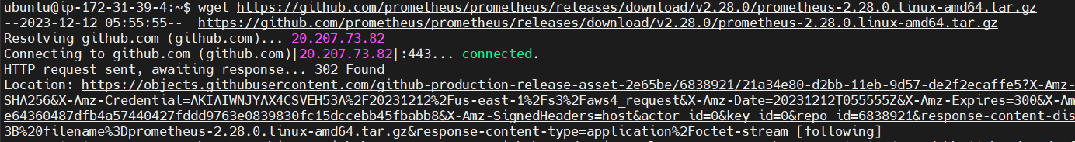
Now, move the prometheus-2.28.0.linux-amd64 directory to /opt/ directory and rename it to prometheus as follows:

Extract the downloaded file:

$ tar -xvf prometheus-2.28.0.linux-amd64.tar.gz
$ sudo mv -v prometheus-2.28.0.linux-amd64 /opt/prometheus

Change the user and group of all the files and directories of the /opt/prometheus/ directory to root:
$ sudo chown -Rfv root:root /opt/prometheus
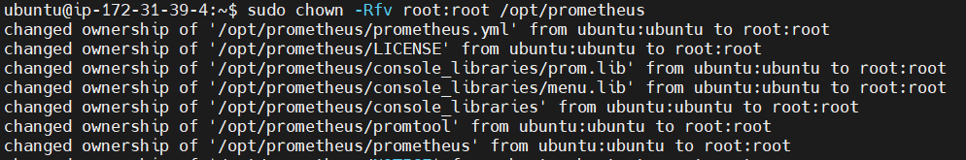
Fix the file and directory permissions of all the files and directories of the /opt/prometheus/ directory:
$ sudo chmod -Rfv 0755 /opt/prometheus

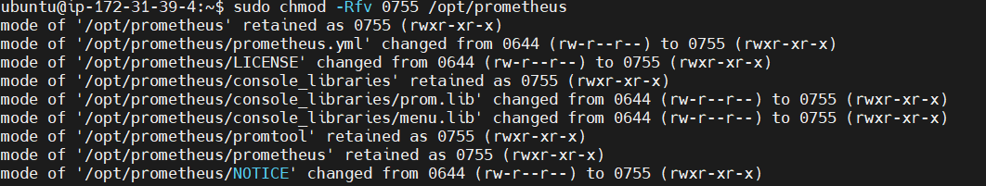
The configuration file of Prometheus is /opt/prometheus/prometheus.yml.
You can open it with the nano text editor as follows:
$ sudo vi /opt/prometheus/prometheus.yml

(optional) If you want, you can remove the comment lines from the configuration file /opt/prometheus/prometheus.yml with the following command:

$ egrep -v '(^[ ]*#)|(^$)' /opt/prometheus/prometheus.yml | sudo tee /opt/prometheus/prometheus.yml
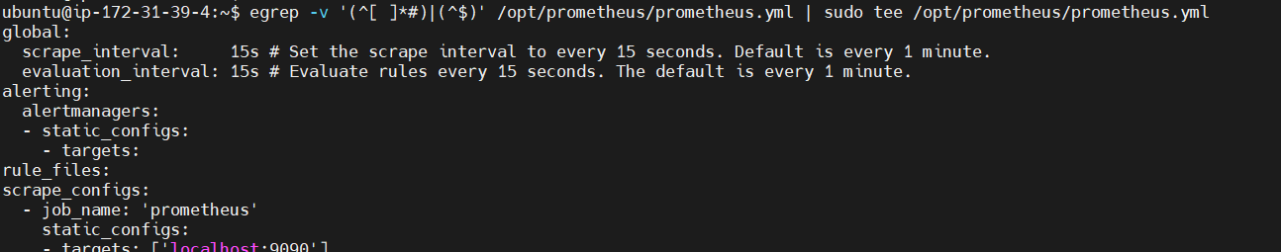

Once all the comment lines are removed, the configuration file /opt/prometheus/prometheus.yml should look as shown in the screenshot above.

$ sudo vi /opt/prometheus/prometheus.yml

After every scrape_interval (15 seconds in this configuration) time, Prometheus will scrape data from the jobs configured in the scrape_configs section.
In the scrape_configs section, you list the targets that Prometheus will scrape data from after every scrape_interval time.
To configure a target, you need the following information:
- A It can be anything and is used to identify the target.
- The DNS name or IP address and the port number of the target in which a Prometheus exporter is available.
By default, only a single target localhost:9090 is configured for the prometheus job. Prometheus itself exports its runtime metrics on the port 9090. So, this target scrapes information about the running Prometheus instance.
After every evaluation_interval time, the rules defined in the rule_files section are evaluated and alerts are sent to the Alert Manager configured in the alerting section. Alerting and Alert Manager is out of the scope of this article. So, I will not cover them here.

Prometheus needs a directory where it can store the metrics that it had collected. In this article, I will store it in the /opt/prometheus/data/ directory.
So, create a new directory data/ in the /opt/prometheus/ directory as follows:

$ sudo mkdir -v /opt/prometheus/data

As you will be running Prometheus as the user prometheus, the /opt/prometheus/data/ directory must be accessible to the user prometheus.
So, change the user and group of the /opt/prometheus/data/ directory to prometheus as follows:

$ sudo chown -Rfv prometheus:prometheus /opt/prometheus/data

Now, you have to create a systemd service file for Prometheus so that you can easily manage (start, stop, restart, and add to startup) the prometheus service with systemd.
To create a systemd service file prometheus.service, run the following command:
$ sudo vi /etc/systemd/system/prometheus.service

prometheus.service file.
[Unit]
Description=Monitoring system and time series database
[Service]
Restart=always
User=prometheus
ExecStart=/opt/prometheus/prometheus --config.file=/opt/prometheus/prometheus.yml --storage.tsdb.path=/opt/prometheus/data
ExecReload=/bin/kill -HUP $MAINPID
TimeoutStopSec=20s
SendSIGKILL=no
LimitNOFILE=8192
[Install]
WantedBy=multi-user.target

For the systemd changes to take effect, run the following command:
$ sudo systemctl daemon-reload

Now, start the prometheus service with the following command:
$ sudo systemctl start prometheus.service

Add the prometheus service to the system startup, so that it automatically starts on boot with the following command:
$ sudo systemctl enable prometheus.service

As you can see, the prometheus service is active/running. It is also enabled (will start automatically on boot).
$ sudo systemctl status prometheus.service

To access Prometheus from UI ip:port http://13.233.122.136:9090/alerts
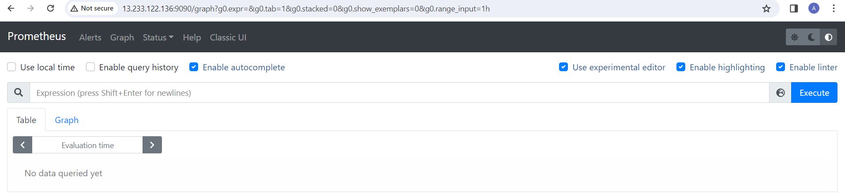

Installing Node Exporter
Node Exporter is used for exporting hardware and operating system metrics that are exposed by the Linux kernel to Prometheus. In this section, I am going to show you how to download the latest version of Node Exporter and install it on Ubuntu 20.04 LTS.

Download the latest version of Node Exporter (v1.1.2 at the time of this writing) with the following command:
$ wget https://github.com/prometheus/node_exporter/releases/download/v1.1.2/node_exporter-1.1.2.linux-amd64.tar.gz

$ tar xzf node_exporter-1.1.2.linux-amd64.tar.gz

In the node_exporter-1.1.2.linux-amd64/ directory, you should find the node_exporter binary file.

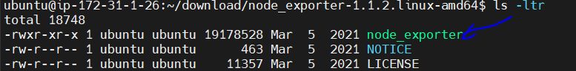

Move the node_exporter binary file from the node_exporter-1.1.2.linux-amd64/ directory to the /usr/local/bin/ directory as follows:

$ sudo mv -v node_exporter-1.1.2.linux-amd64/node_exporter /usr/local/bin/

If your file is in different patch, We need to update file patch as shown below
$ sudo mv -v /home/ubuntu/download/node_exporter-1.1.2.linux-amd64/node_exporter /usr/local/bin/

Also, change the user and group of the /usr/local/bin/node_exporter binary file to root as follows:
$ sudo chown root:root /usr/local/bin/node_exporter
Node Exporter should be installed.
Now, you should be able to run node_exporter just like any other command.
$ node_exporter --version
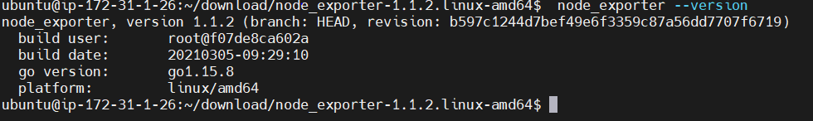
Now, you have to create a systemd service file for Node Exporter so that you can easily manage (start, stop, restart, and add to startup) the node-exporter service with systemd.
To create a systemd service file node-exporter.service, run the following command:
$ sudo vi /etc/systemd/system/node-exporter.service
Type in the following lines of codes in the node-exporter.service file.
[Unit]
Description=Prometheus exporter for machine metrics
[Service]
Restart=always
User=prometheus
ExecStart=/usr/local/bin/node_exporter
ExecReload=/bin/kill -HUP $MAINPID
TimeoutStopSec=20s
SendSIGKILL=no
[Install]
WantedBy=multi-user.target

For the systemd changes to take effect, run the following command:
$ sudo systemctl daemon-reload
Now, start the node-exporter service with the following command:
$ sudo systemctl start node-exporter.service

Add the node-exporter service to the system startup so that it automatically starts on boot with the following command:
$ sudo systemctl enable node-exporter.service
As you can see, the node-exporter service is active/running. It is also enabled (will start automatically on boot).
$ sudo systemctl status node-exporter.service
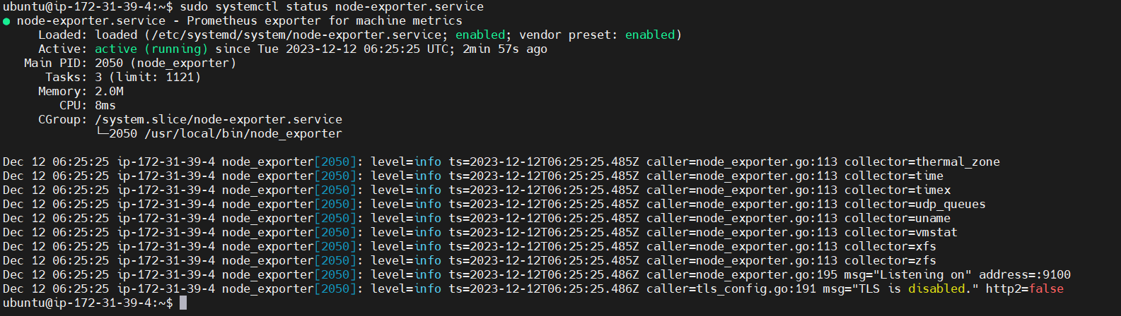
To check whether Node Exporter is working, visit the URL http://ip:9100/metrics from your favorite web browser. If everything goes well, you should see the page, as shown in the screenshot below
http://13.235.242.200:9100/metrics
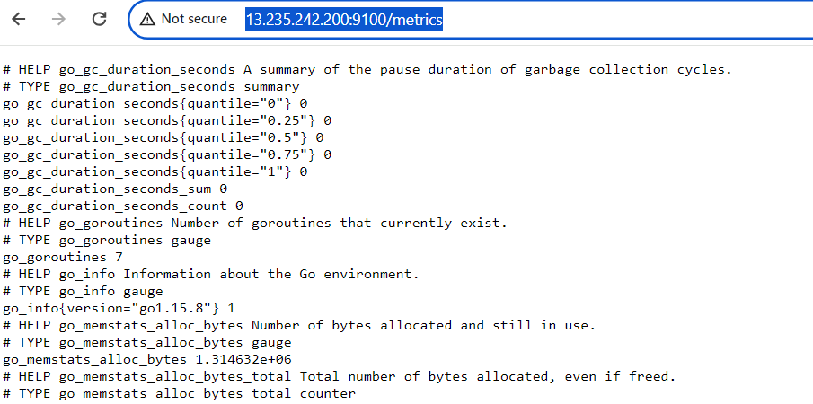.

Adding Node Exporter to Prometheus
Once you have installed Node Exporter on the server that you want to monitor with Prometheus, you have to configure Prometheus so that it collects metrics from that server. All you have to do is add the server where you’ve installed Node Exporter as a target on Prometheus.
To do that, open the prometheus.yml configuration file as follows:
$ sudo vi /opt/prometheus/prometheus.yml

Add the following lines in the scrape_configs section of prometheus.yml file. Make sure to indent everything correctly to avoid syntax errors.
- job_name: 'node_exporter'
static_configs:
- targets: ['13.235.242.200:9100']

If you want to monitor multiple servers with Prometheus, you will have to install Node Exporter on each one of them and create a new job for each one of them. In that case, you can use the hostname of your server as its job name to make identifying each target easier.
For the changes to take effect, restart Prometheus with the following command:
$ sudo systemctl restart prometheus.service

Now, visit the URL http://13.235.242.200:9090/targets from your favorite web browser and you should see a new entry node_exporter, as marked in the screenshot below. Click on show more.

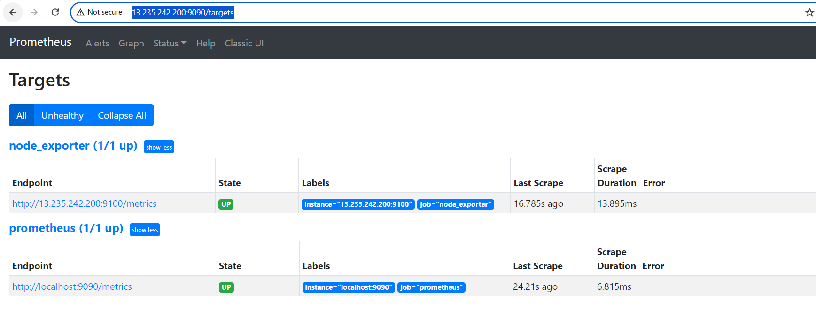
As you can see, the node_exporter target is in the UP state. So, Node Exporter is working just fine and Prometheus can collect metrics from the server where you’ve installed Node Exporter.

We can add multiple nodes to Prometheus to scrape the metrics from remote servers/targets servers, So that we need to install Node exporter on the servers.
Follow same steps for installing node exporter
Note: we need to add prometheus user before installing the node exporter.
$ sudo apt update && sudo apt install wget -y
$ sudo useradd --system --no-create-home --shell /usr/sbin/nologin prometheus
Once installing is completed we need to update Prometheus configuration file with target ip and port number.
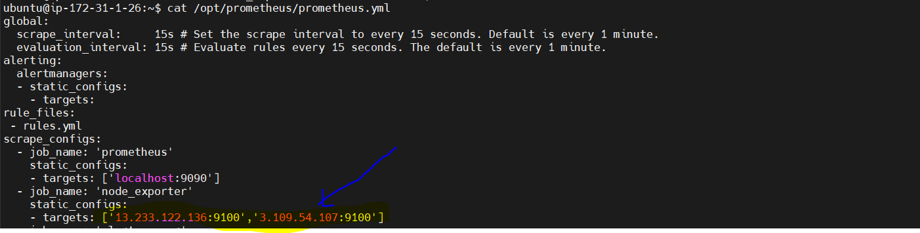
We can add n number of targets (node_exporters)
Using Prometheus
In this section, I am going to show you how to use Prometheus to monitor the network traffic of your computer (where you have installed Node Exporter). This should help you get a basic idea of how Prometheus works.
First, navigate to the Prometheus Graph page (http://13.235.242.200:9090) from your web browser.

In the Expression section, type in Prometheus expressions and click on Execute to execute them.

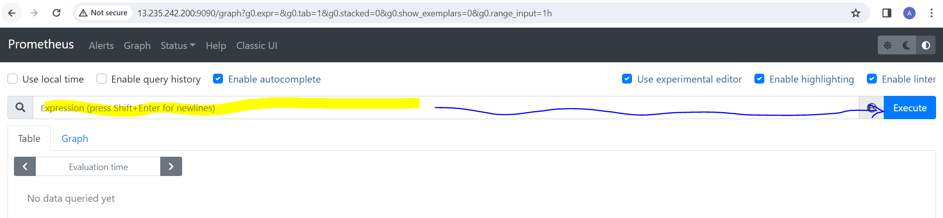

The properties exported by Node Exporter starts with node_.
To monitor the total bytes received (downloaded) by the computer, type in node_network_receive_bytes_total and click on Execute.

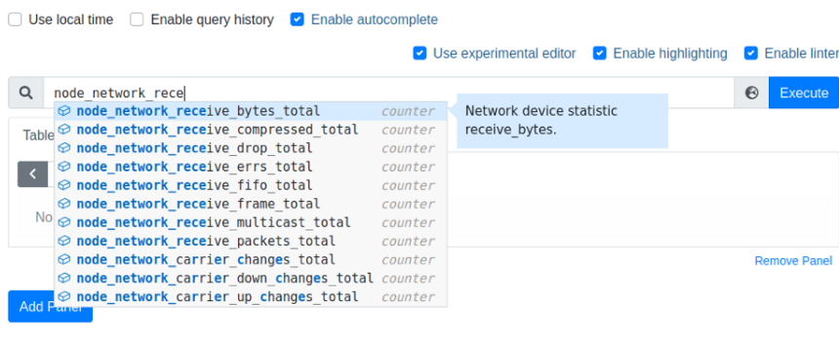

On the Table tab, the current value of your selected property should be displayed.

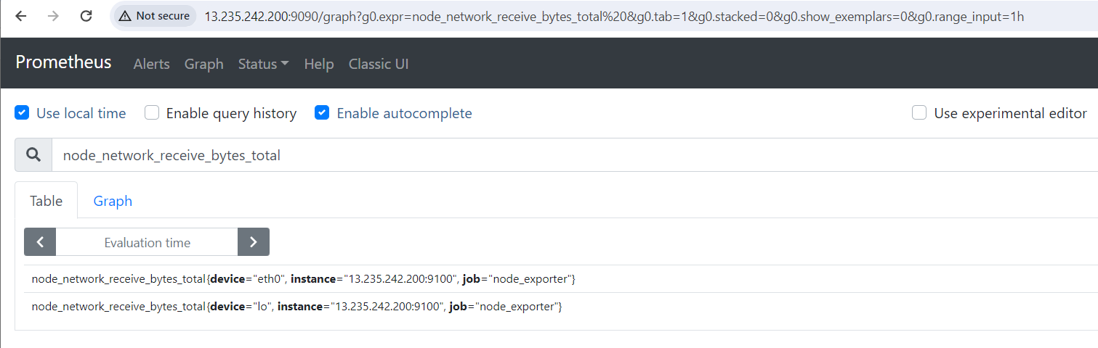

You can see the download speed (the bytes received/downloaded per second) of your computer using the rate() function on the node_network_receive_bytes_total counter.
To do that, type in the expression rate (node_network_receive_bytes_total[1m]) and click on Execute. The graph should display how many bytes of data your computer received per second, as you can see in the screenshot below.

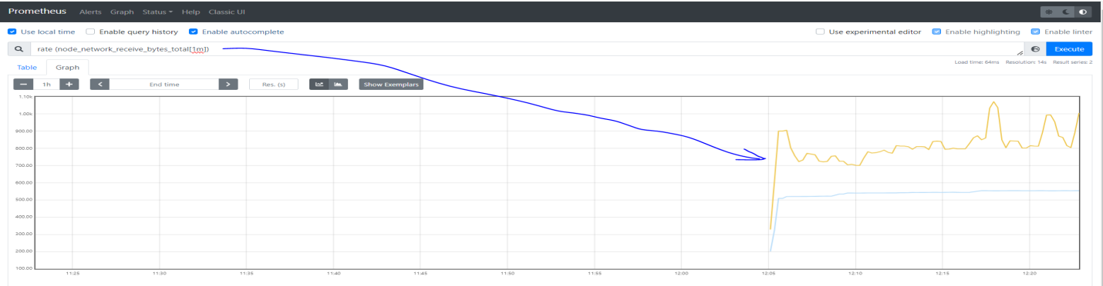
In the same way, you can use the rate (node_network_transmit_bytes_total[1m]) expression to display the number of bytes your computer uploaded per second.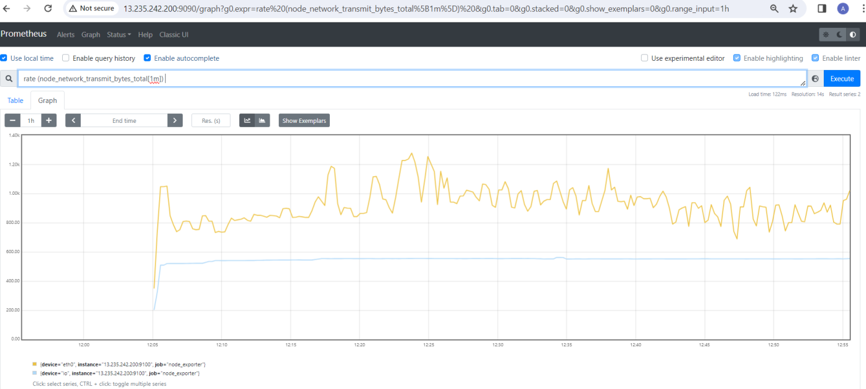

Installing Alert Manager:
You can download the latest version of Alert Manager from the official website of Prometheus and install it on Ubuntu 20.04 LTS very easily.

$ wget https://github.com/prometheus/alertmanager/releases/download/v0.22.2/alertmanager-0.22.2.linux-amd64.tar.gz

$ tar xzf alertmanager-0.22.2.linux-amd64.tar.gz

Now, move the alertmanager-0.22.2.linux-amd64 directory to /opt/ directory and rename it to alertmanager as follows:
$ sudo mv -v alertmanager-0.22.2.linux-amd64 /opt/alertmanager
Change the user and group of all the files and directories of the /opt/alertmanager/ directory to root as follows:
$ sudo chown -Rfv root:root /opt/alertmanager

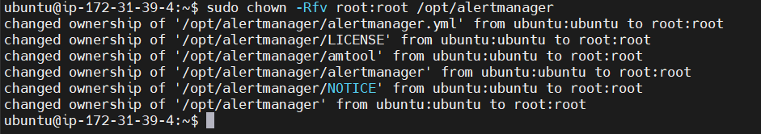
In the /opt/alertmanager directory, you should find the alertmanager binary and the Alert Manager configuration file alertmanager.yml, as marked in the screenshot below. You will use them later. So, just keep that in mind.
$ ls -lrt /opt/alertmanager
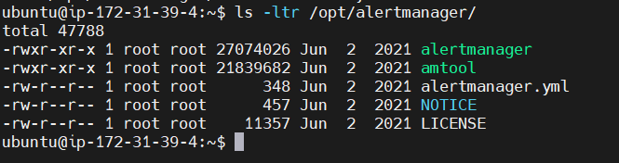

Creating a Data Directory:
Alert Manager needs a directory where it can store its data. As you will be running Alert Manager as the prometheus system user, the prometheus system user must have access (read, write, and execute permissions) to that data directory.
You can create the data/ directory in the /opt/alertmanager/ directory as follows:
$ sudo mkdir -v /opt/alertmanager/data
Change the owner and group of the /opt/alertmanager/data/ directory to prometheus with the following command:
$ sudo chown -Rfv prometheus:prometheus /opt/alertmanager/data
The owner and group of the /opt/alertmanager/data/ directory should be changed to prometheus, as shown in the screenshot below.
$ ls -lrt /opt/alertmanager
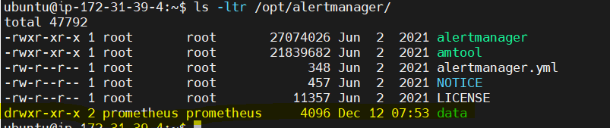

Starting Alert Manager on Boot:
Now, you have to create a systemd service file for Alert Manager so that you can easily manage (start, stop, restart, and add to startup) the alertmanager service with systemd.
To create a systemd service file alertmanager.service, run the following command:
$ sudo vi /etc/systemd/system/alertmanager.service
Type in the following lines in the alertmanager.service file.
[Unit]
Description=Alertmanager for prometheus
[Service]
Restart=always
User=prometheus
ExecStart=/opt/alertmanager/alertmanager --config.file=/opt/alertmanager/alertmanager.yml --storage.path=/opt/alertmanager/data
ExecReload=/bin/kill -HUP $MAINPID
TimeoutStopSec=20s
SendSIGKILL=no
[Install]
WantedBy=multi-user.target

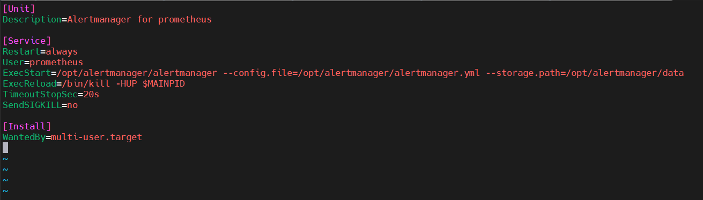
For the systemd changes to take effect, run the following command:
$ sudo systemctl daemon-reload
Now, start the alertmanager service with the following command:
$ sudo systemctl start alertmanager.service
Add the alertmanager service to the system startup so that it automatically starts on boot with the following command:
$ sudo systemctl enable alertmanager.service
As you can see, the alertmanager service is active/running. It is also enabled (it will start automatically on boot).
$ sudo systemctl status alertmanager.service
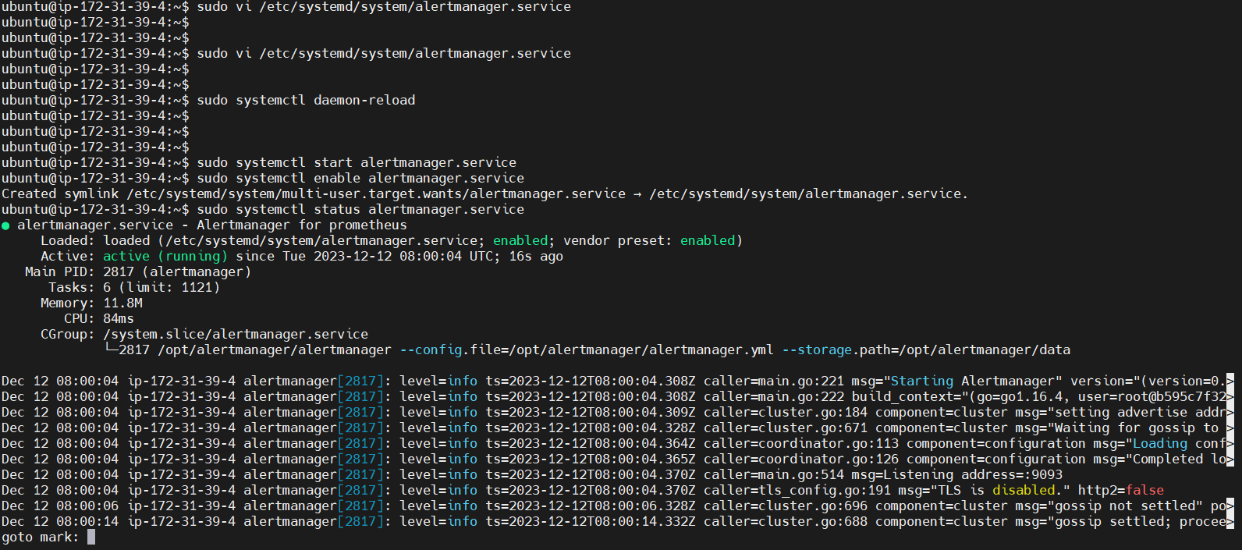

Configuring Prometheus:
Now, you have to configure Prometheus to use Alert Manager. You can also monitor Alert Manager with Prometheus. I will show you how to do both in this section.
Now, open the Prometheus configuration file /opt/prometheus/prometheus.yml with the VI text editor as follows:
$ sudo vi /opt/prometheus/prometheus.yml
Type in the following lines in the scrape_configs section to add Alert Manager for monitoring with Prometheus.
- job_name: 'alertmanager'
static_configs:
- targets: ['13.235.242.200:9093']

Also, type in the IP address and port number of Alert Manager in the alerting > alertmanagers section as marked in the screenshot below.
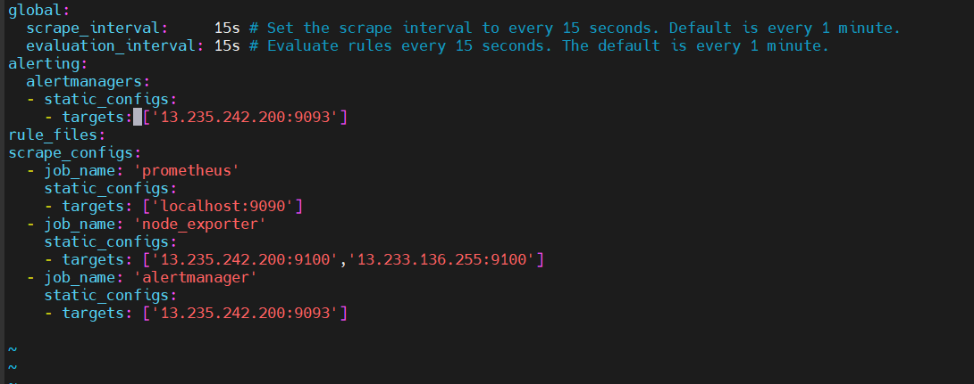

For the changes to take effect, restart the prometheus service as follows:
$ sudo systemctl restart prometheus.service

Visit the URL http://13.235.242.200:9090/targets from your web browser, and you should see that alertmanager is in the UP state. So, Prometheus can access Alert Manager just fine.

NOTE: I have installed Prometheus and Alert Manager on the same computer. So, the IP address of my Prometheus instance is the same as Alert Managers. If you have installed Prometheus on a different computer, make the necessary adjustments from now on.

Visit the URL http://13.233.122.136:9093/ from your web server, you should see alertmanager dashboard as below.
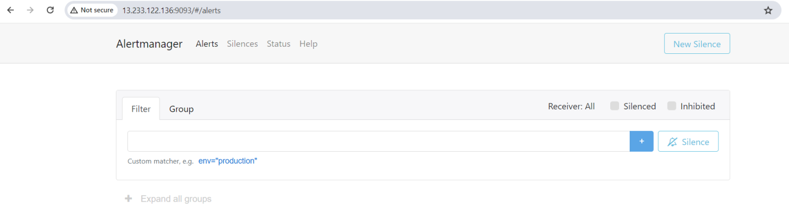

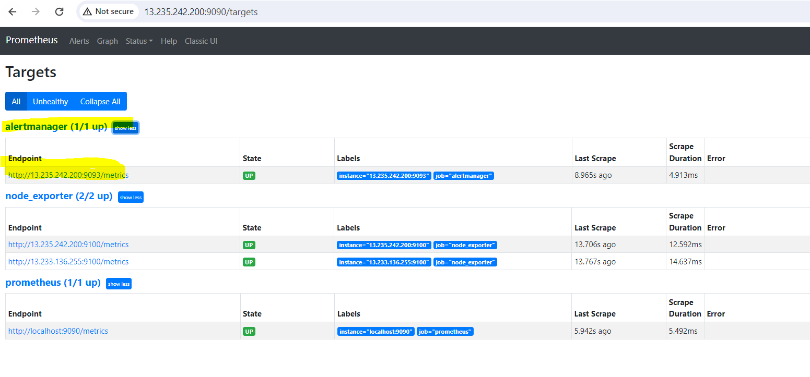

Creating a Prometheus Alert Rule:
On Prometheus, you can use the up expression to find the state of the targets added to Prometheus, as shown in the screenshot below.
The targets that are in the UP state (running and accessible to Prometheus) will have the value 1, and targets that are not in the UP (or DOWN) state (not running or inaccessible to Prometheus) will have the value 0.

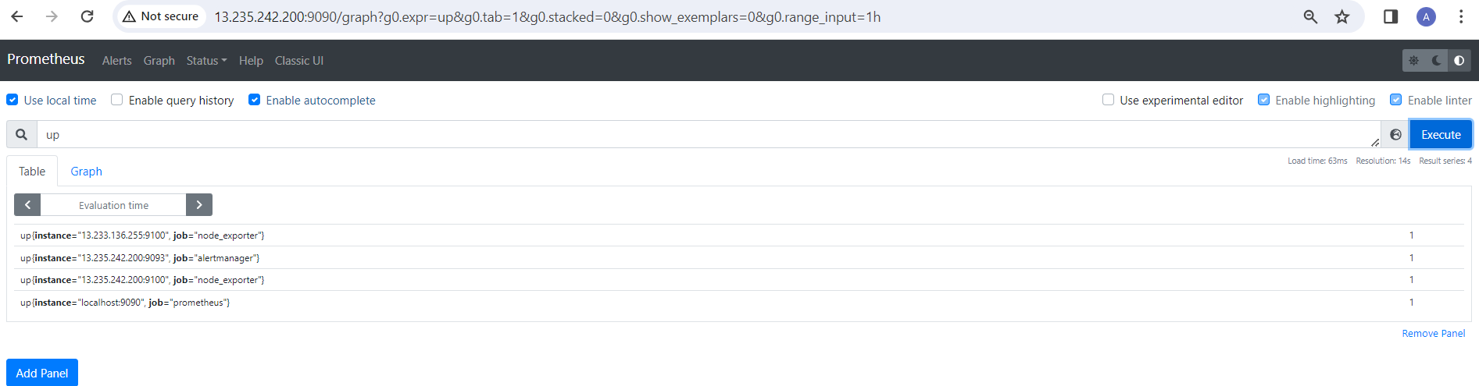

If you stop one of the targets – node_exporter (let’s say).
$ sudo systemctl stop node-exporter.service

The up value of that target should be 0, as you can see in the screenshot below. You get the idea.
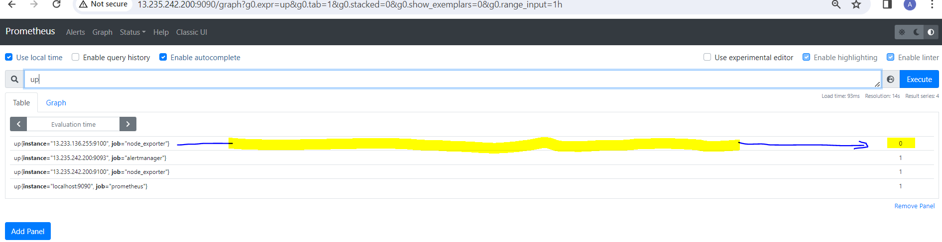

So, you can use the up == 0 expressions to list only the targets that are not running or inaccessible to Prometheus, as you can see in the screenshot below.
This expression can be used to create a Prometheus Alert and send alerts to Alert Manager when one or more targets are not running or inaccessible to Prometheus.
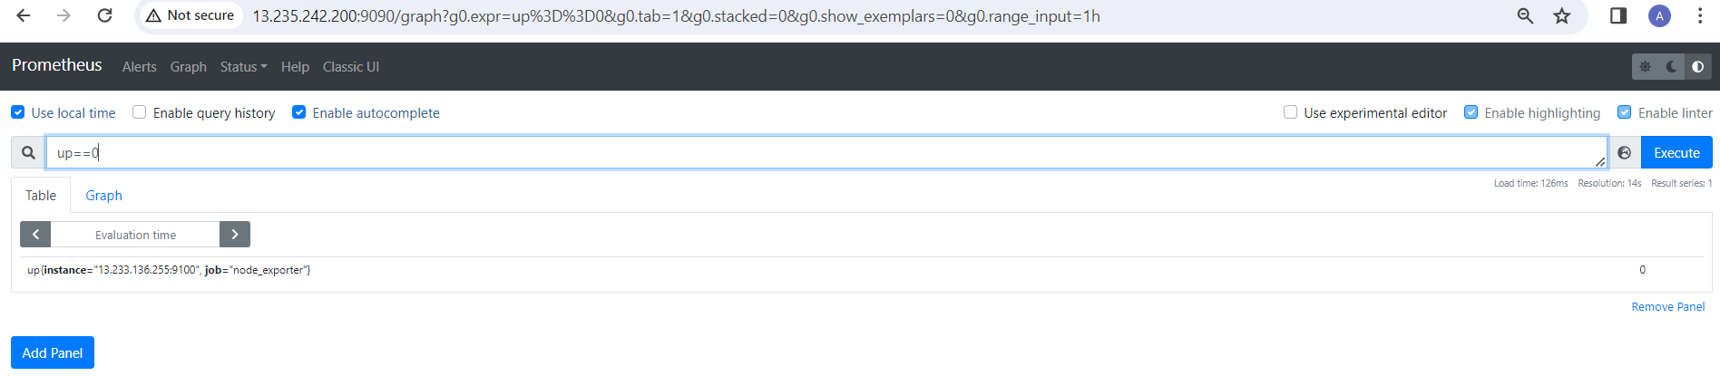
To create a Prometheus Alert, create a new file rules.yml in the /opt/prometheus/ directory as follows:
$ sudo vi /opt/prometheus/rules.yml
Now, type in the following lines in the rules.yml file.
groups:
- name: test
rules:
- alert: InstanceDown
expr: up == 0
for: 1m
Here, the alert InstanceDown will be fired when targets are not running or inaccessible to Prometheus (that is up == 0) for a minute (1m).
Now, open the Prometheus configuration file /opt/prometheus/prometheus.yml with the nano text editor as follows:
$ sudo vi /opt/prometheus/prometheus.yml
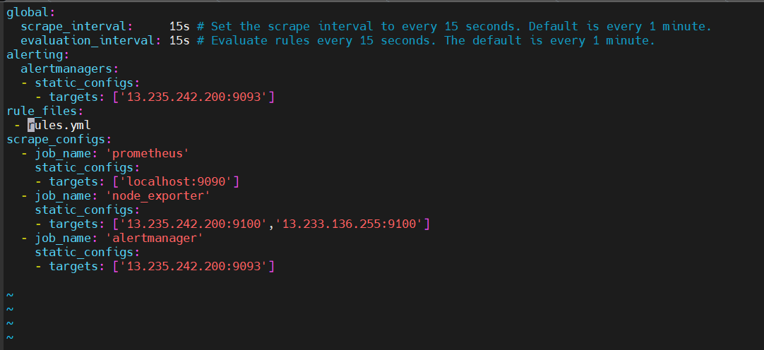
Another important option of the prometheus.yml file is evaluation_interval. Prometheus will check whether any rules matched every evaluation_interval time. The default is 15s (15 seconds). So, the Alert rules in the rules.yml file will be checked every 15 seconds.

For the changes to take effect, restart the prometheus service as follows:
$ sudo systemctl restart prometheus.service
Now, navigate to the URL http://13.235.242.200:9090/alerts from your favorite web browser, and you should see the rule InstanceDown that you’ve just added.

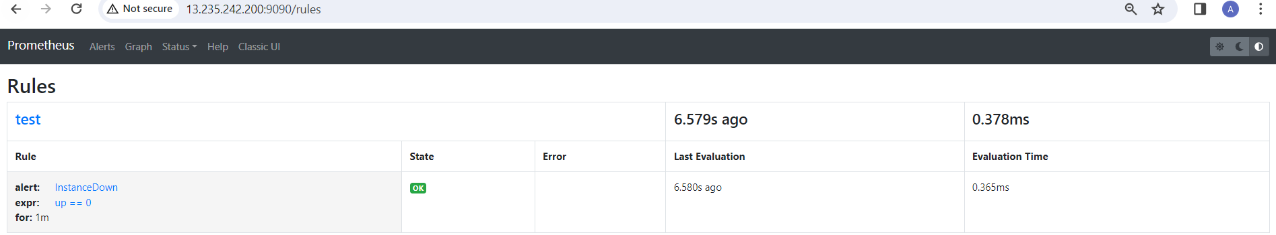

Navigate to the URL http://13.235.242.200:9090/alerts from your favorite web browser, and you should see the state of the alert InstanceDown, as you can see in the screenshot below.
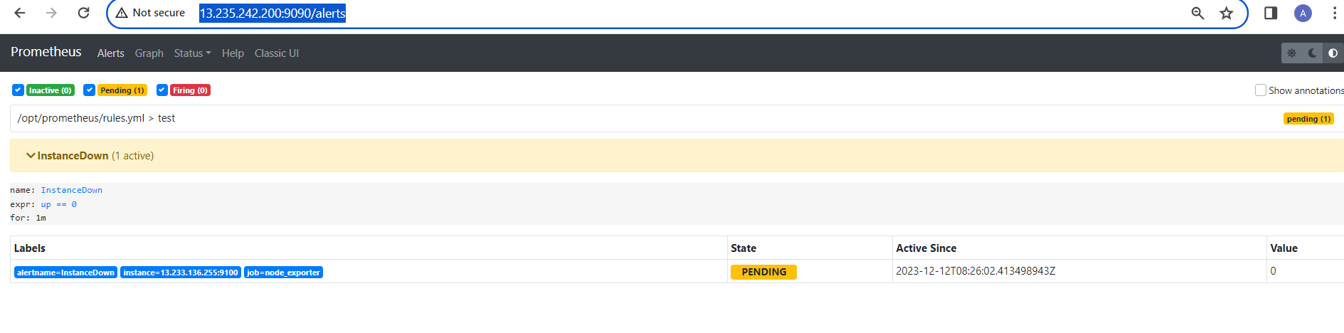

After a minute has passed, the alert InstanceDown should be in the FIRING state.
